Planning the Future of New York City
Adam Glassman’s Seminar 4

Rachel Szekely, Tech Fellow
Email: Rachel.szekely@verizon.net

Team Mapping Project

My Google Maps (OR, Google Maps + PowerPoint)

Basic user guide: http://maps.google.com/support/bin/answer.py?answer=68480

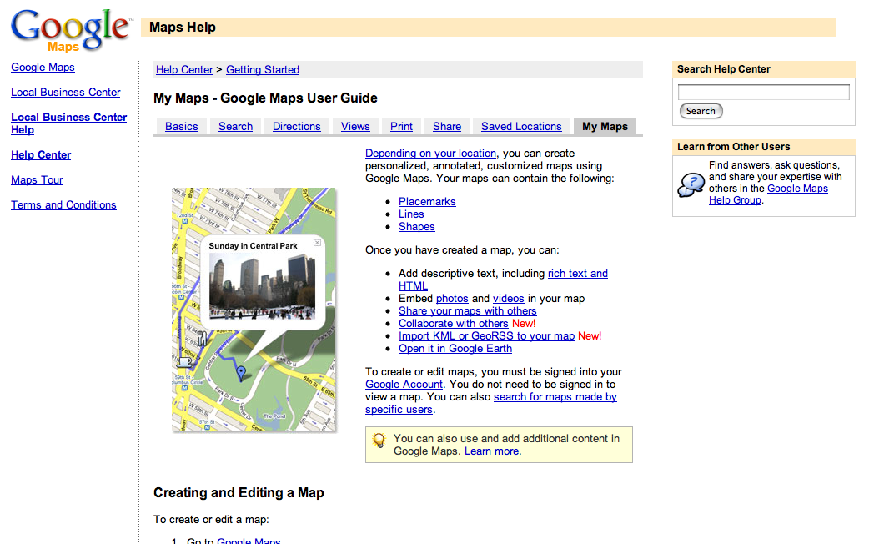

Google Home

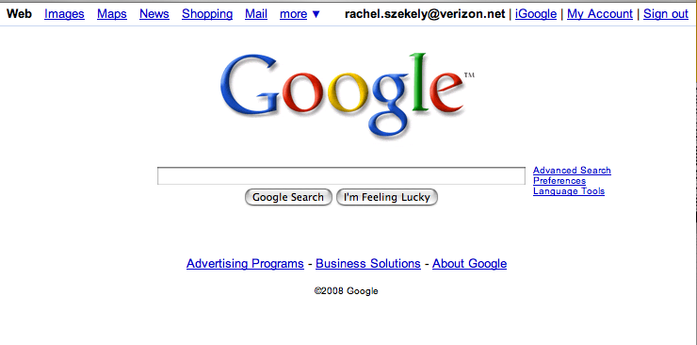

Google Maps Home

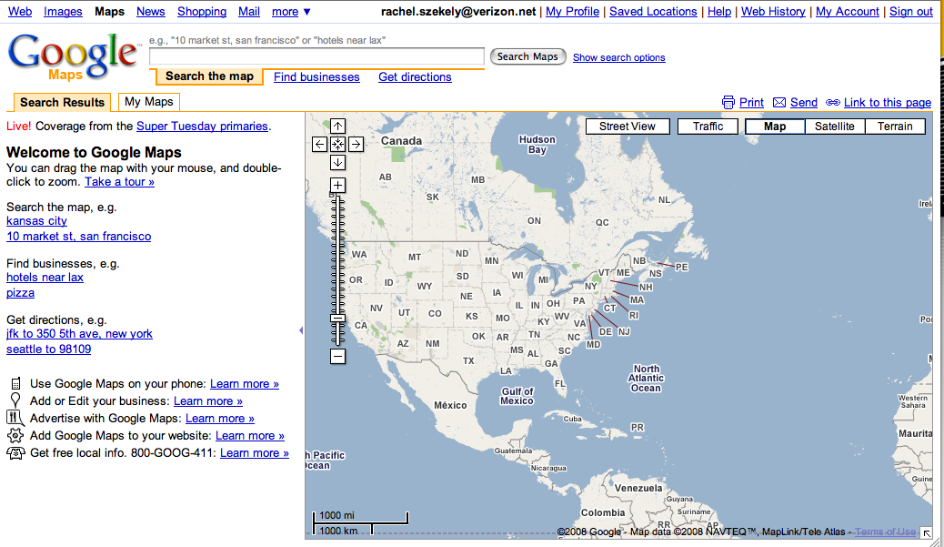

Google Maps Results

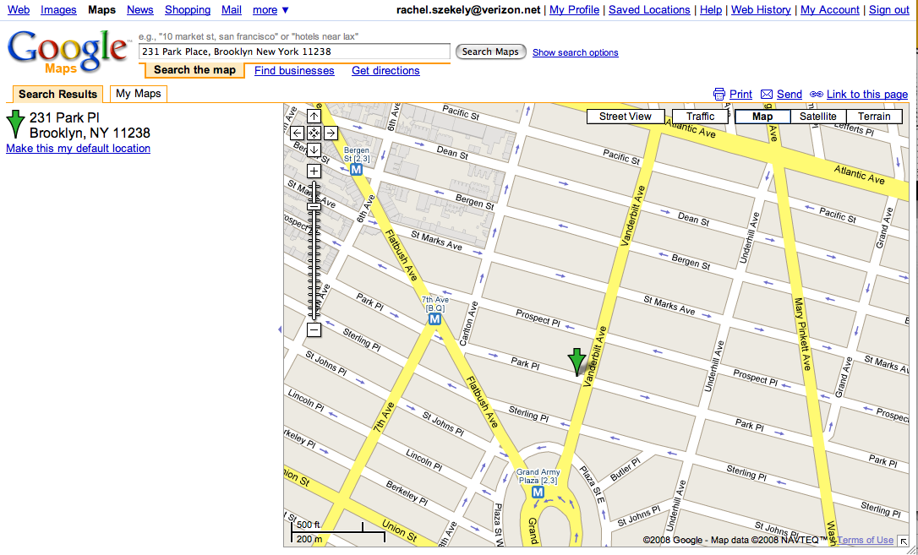

MySpace Initiative

- Create Profile for team on MySpace & customize

- Build your online community—Seek endorsements and friends, join organizations

- Shoot Video with camera from A/V

- Edit Video with iMovie *Next Workshop

- Upload Video to MySpace

MySpace Home

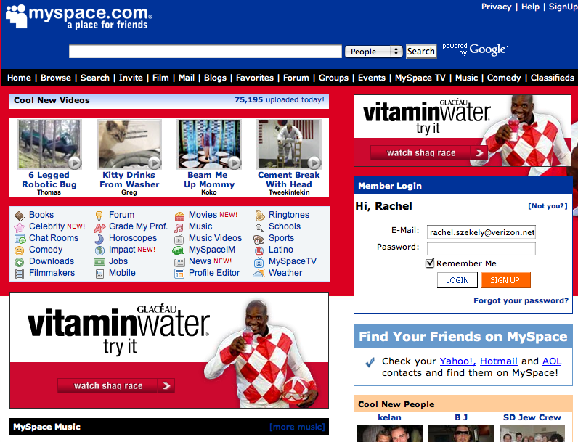

Profile Page

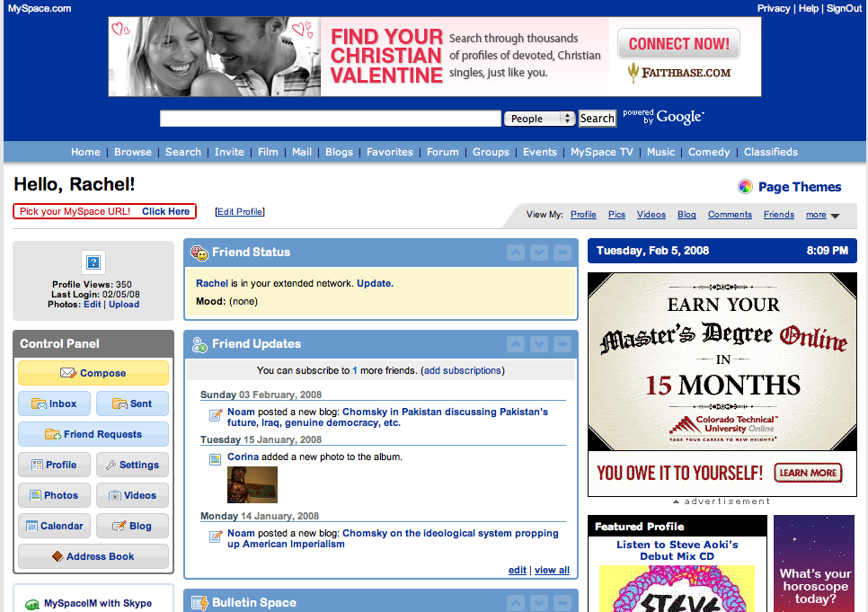

Upload Video



